Tax Year 2023

Wage File Upload (WFU)

Tutorial

Follow these instructions to submit/resubmit a W-2 Wage File or a W-2c Wage File to the Social Security Administration (SSA) using the Wage File Upload application.
For information on preparing formatted W-2 files for electronic filing (EFW2, formerly MMREF-1), or W-2c files (EFW2C, formerly MMREF-2), go to the Specifications for Filing Forms W-2 and W-2c (EFW2/EFW2C) page on the employer web site.

Contents
1.0 Access the Wage File Upload Application 3
2.0 What’s in the File 4
3.0 Upload File 4
3.1 Upload a W-2 File 5
3.2 Upload a W-2c File 6
4.0 Respond to a Resubmission Notice 7
5.0 Success 10
6.0 Failure 11
6.1 Errors on File Level 11
6.2 Other Errors 12
6.2.1 Errors on File Format 13
6.2.2 Errors on Field Level 13
7.0 File Summary 14
7.1 File Summary for Success 14
7.2 File Summary for Failure 14
8.0 Error Results 15
9.0 Other Features—Pop Ups 17
9.1 Acknowledgement of Receipt Pop Up 17
9.2 Help Pop Up 18
9.3 Learn More About This File Format Pop Up 19
9.4 Uploading Your Wage File Is In Progress Pop Up 20
9.5 Table Data Loading Is In Progress Pop Up 20
10.0 Feedback 20

Access the Wage File Upload Application
Select the Upload Formatted Wage File tab on the EWR homepage to access the Wage File Upload application. Select the Submit a Formatted Wage File link. The system displays the “What’s in the File” page.
See “Access EWR Suite of Services Tutorial” for how to access the EWR homepage.
Selecting the Resubmit your Formatted Wage File link in the Resubmission Notice section can also access the Wage File Upload application.
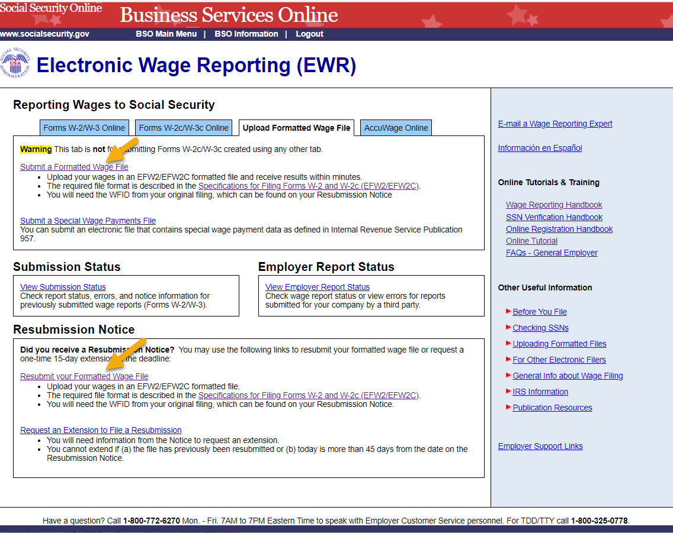

What’s in the File
- Select the W-2/W-3 forms for Tax Year 2023 or previous tax year (EFW2) radio button to upload a W-2 file. See the Upload File section for more information.
- Select the W-2c/W-3c forms to correct mistakes on previously processed W-2 forms (EFW2C) radio button to upload a W-2c file. See the Upload File section for more information.
- Select the Response to a Resubmission Notice radio button to resubmit a W-2/W-2c file after you received a Resubmission Notice. See the Respond to a Resubmission Notice section for more information.
- Select the EWR Home link in the header. The system displays the EWR homepage.
- Select the Help link in the header. The system displays a pop up window. See the Help Pop Up in the Other Features section for more information.
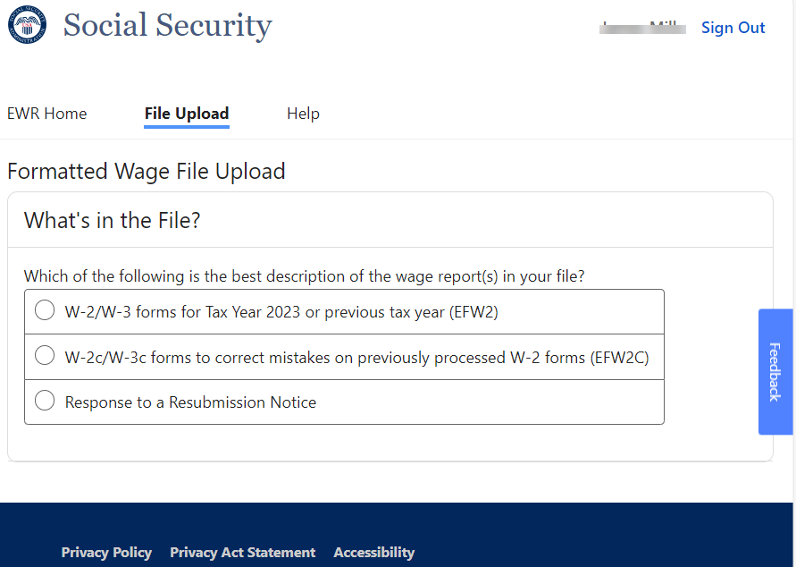

Upload File
When the W-2/W-3 forms for Tax Year 2023 or previous tax year (EFW2) radio button or the W-2c/W-3c forms to correct mistakes on previously processed W-2 forms (EFW2C) radio button is selected, the Upload File section with a Browse button will be displayed. You can choose a file to upload.

Upload a W-2 File
- When the W-2/W-3 forms for Tax Year 2023 or previous tax year (EFW2) radio button is selected, the system will display an Upload File section below the radio buttons. The system is ready to accept a properly formatted EFW2 File.
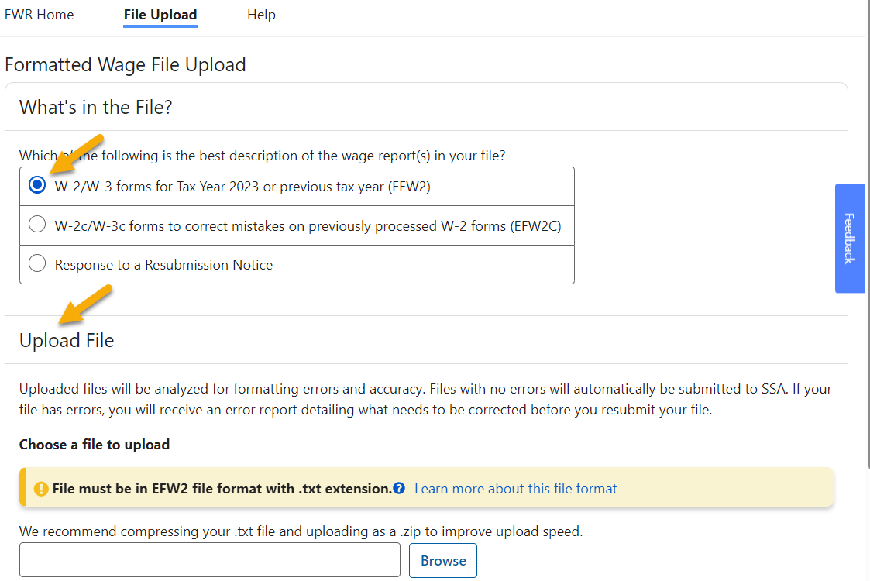
- Select the Browse button, then choose a file to upload. The system displays the Upload File button.
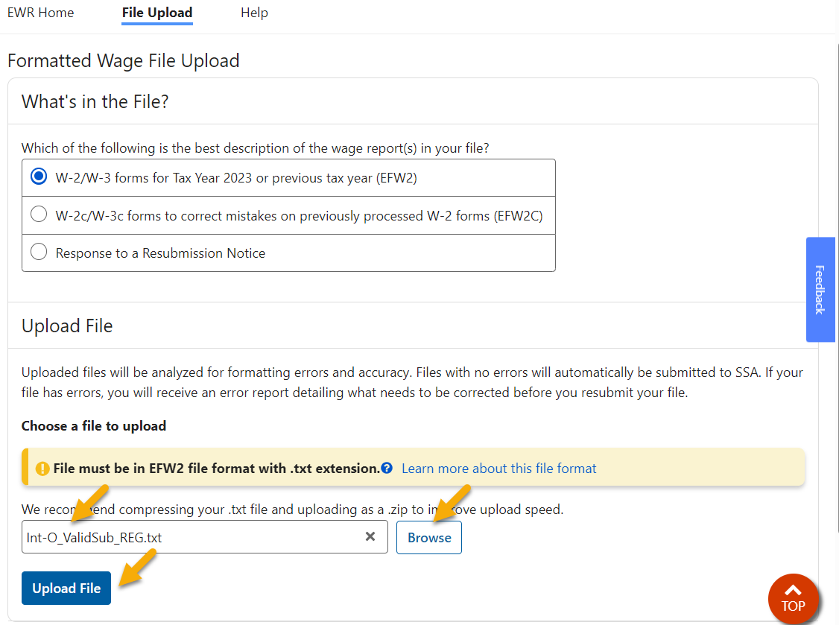
- Select the Upload File button. If the file passes the preliminary checks, the system will display a success page; if the file fails the preliminary checks, the system will display a failure message on the Upload File page or a failure page with failure information and instructions on what to do next. See the Success section and the Failure section for more information.
Note:
If the file is large, the upload process might take long enough for an “in progress” pop up to be displayed. See Uploading Your Wage File Is In Progress section in the Other Features section for more information.

Upload a W-2c File
- When the W-2c/W-3c forms to correct mistakes on previously processed W-2 forms (EFW2C) radio button is selected, the system will display an Upload File section below the radio buttons. The system is ready to accept a properly formatted EFW2C File.
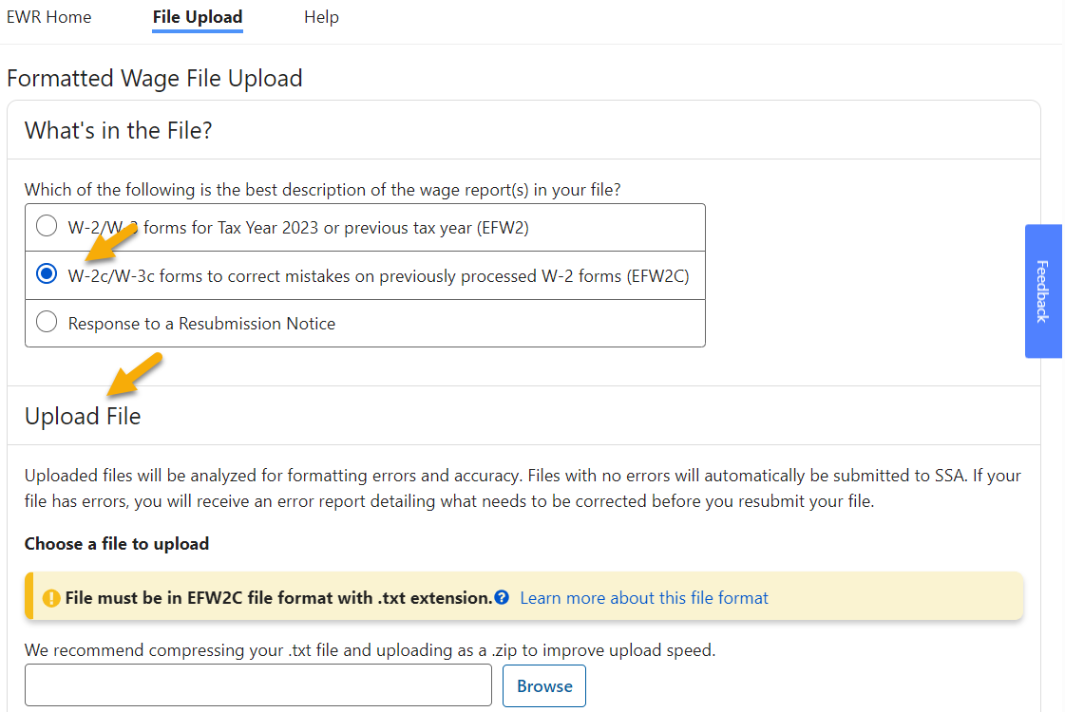

- Select the Browse button, then choose a file to upload. The system displays the Upload File button.
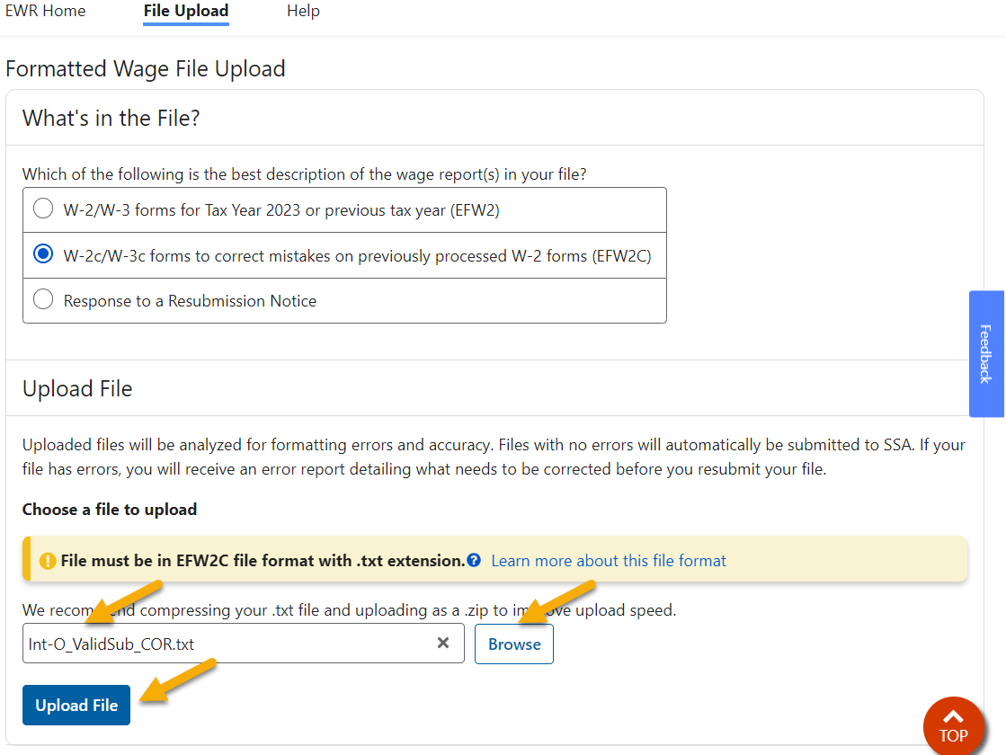
- Select the Upload File button. If the file passes the preliminary checks, the system will display a success page; if the file fails the preliminary checks, the system will display a failure message on the Upload File page or a failure page with failure information and instructions on what to do next. See the Success section and the Failure section for more information.
Note:
If the file is large, the upload process might take long enough for an “in progress” pop up to be displayed. See Uploading Your Wage File Is In Progress in the Other Features section for more information.

Respond to a Resubmission Notice
If you received a Resubmission Notice, you need to resubmit those wage files that failed after fixing the errors.
- On the What’s in the File page within the Wage File Upload application, select the Response to a Resubmission Notice radio button. The system displays the Response to a Resubmission Notice section with a Select Eligible Wage File button below all radio buttons. You are eligible to use this option ONLY if you received a Resubmission Notice from SSA.
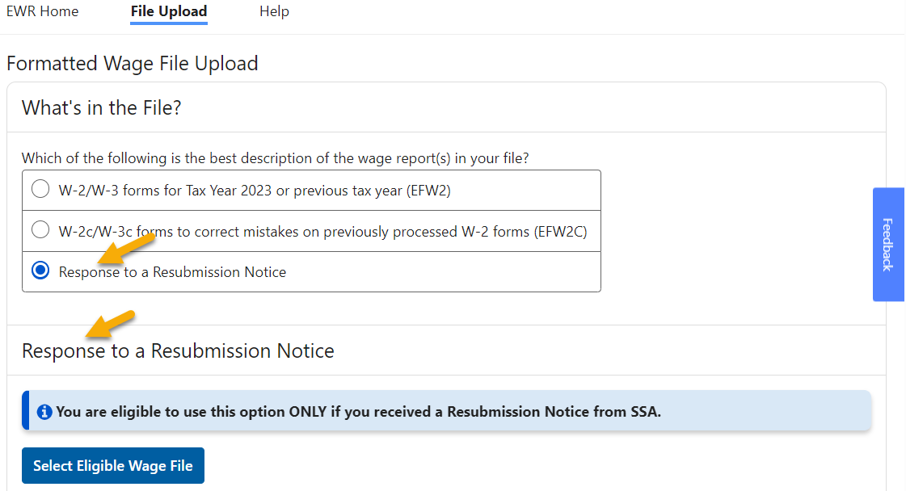
- Select the Select Eligible Wage File button. The system displays a pop up window.
  - If you have resubmission eligible files, they will be displayed in a table. Only those WFIDs associated with the failed files originally submitted under your User ID will be displayed.
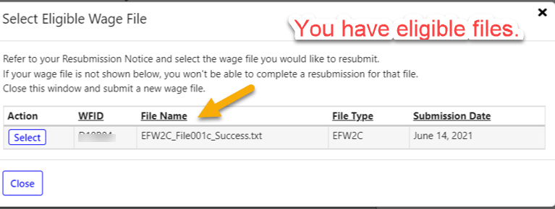
  - If you do not have resubmission eligible files, the system will display “No eligible wage files found” in the table.
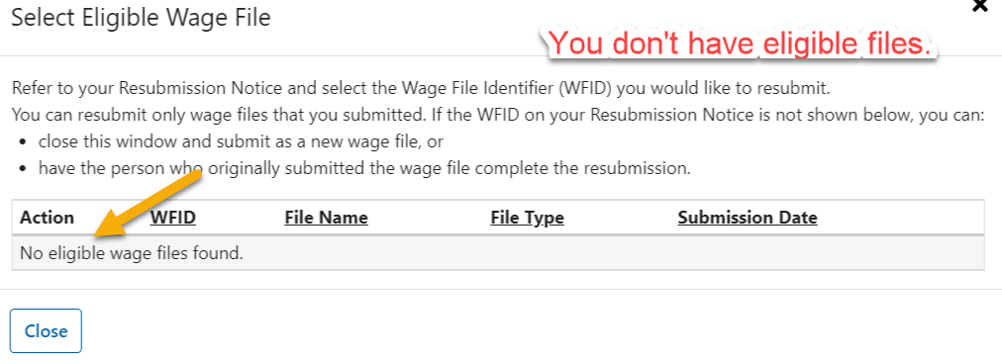
- Select the Select button associated with the WFID you want to resubmit a file for, the pop up window will be disappeared and the selected WFID/File Name will be displayed in a “You selected” table. The Upload File section will also be displayed.
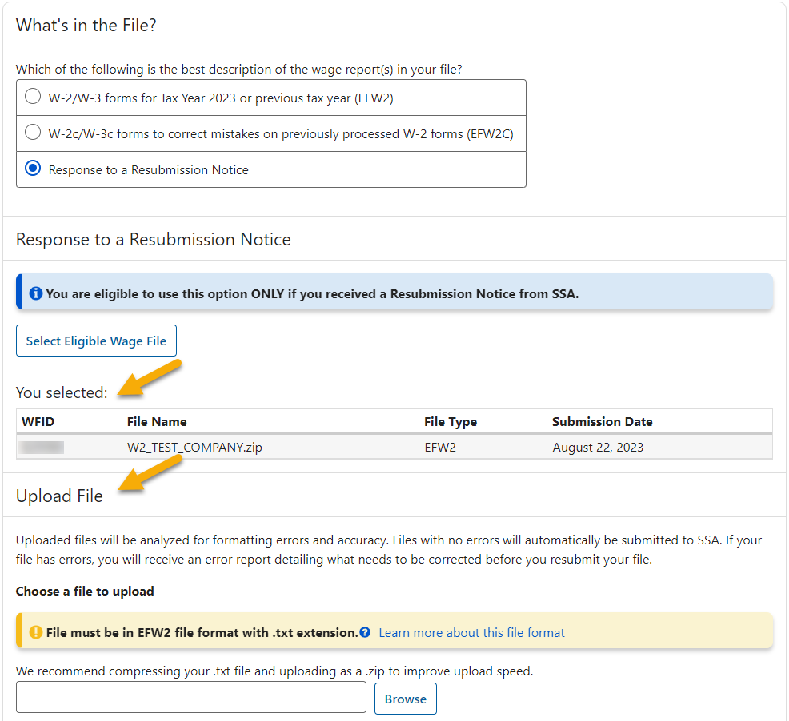
- Select the Browse button, then choose a file to upload. The system displays the Upload File button.
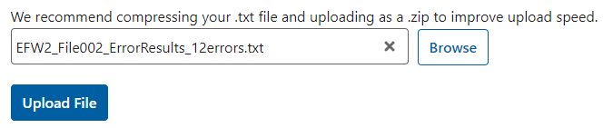
- Select the Upload File button. If the file passes the preliminary checks, the system will display a success page with a Wage File Identifier (WFID) as given on the Resubmission Notice you received. See the Success section and the File Summary for Success section for more information. If the file fails the preliminary checks, the system will display a failure message on the Upload File page or a failure page with failure information and instructions on what to do next. See the Failure section, the File Summary for Failure section, the Error Results section, and the Error Details section for more information.
Note:
If the file is large, the upload process might take long enough for an “in progress” pop up to be displayed. See Uploading Your Wage File Is In Progress section in the Other Features section for more information.

Success
When the uploaded file passes the preliminary checks, it will be automatically submitted to the Social Security Administration and the system will display a success page.
Note:
Some conditions cannot be checked during the file upload process and could still cause a REJECT later in the process. If your submission has a REJECT status, you will be notified with a Resubmission Notice by email.
On the success page:
- The Submission Status link will take you to the Submission Status application. See the TY23 Submission Status tutorial for more information.
- The Wage File Identifier (WFID) is the proof of your submission. You will need the WFID to check the status of your submission in the Submission Status application and for all communications related to the submission with SSA.
- Select the Print Receipt button. The system displays the Acknowledgement of Receipt pop up. See the Acknowledgement of Receipt pop up section in the Other Features section for more information.
- Select the Upload New File button. The system displays the What’s in the File page.
- Select the EWR Home button. The system displays the EWR homepage.
- File Summary section displays some details of your submitted file. See the File Summary section for more information. If the information displayed is not the same as the file information shown on your computer, contact SSA Support at 1-888-772-2970 (TTY 1-800-325-0778).

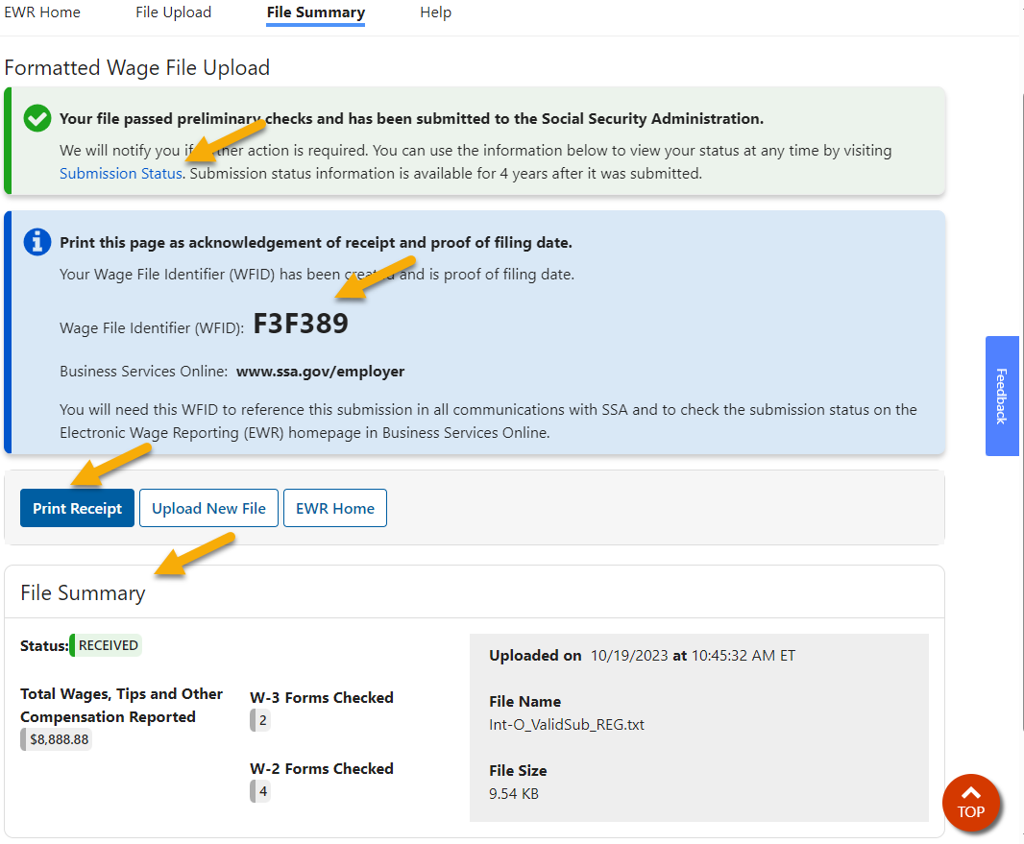

Failure
When the uploaded file fails the preliminary checks, it will not be automatically submitted to SSA. The system displays an error message on the Upload File page or a failure page with the failure information and the instructions on what to do next.

Errors on File Level
If the system cannot open your file, an error message will be displayed on the Upload File page. Some of the errors on opening a file are:
- Invalid Zip file
- Invalid file size
- Invalid file name
- Invalid file extension

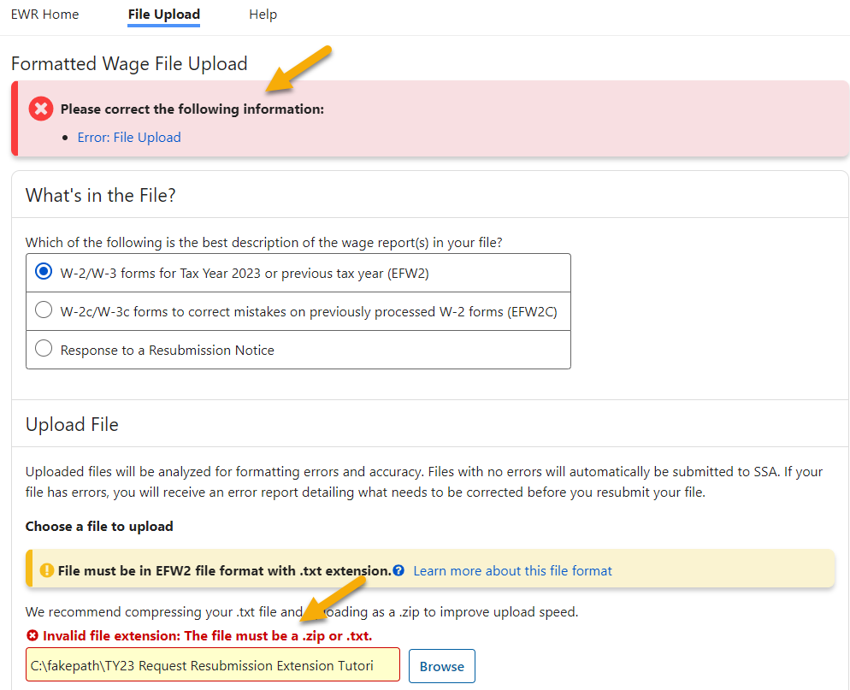

Other Errors
If your file has errors other than the file level error, the system will display a failure page with the failure information and the instructions on what to do next. The first section (banner) on the failure page for all errors will be the same; the second section (banner) on the failure page identifies the specific errors.
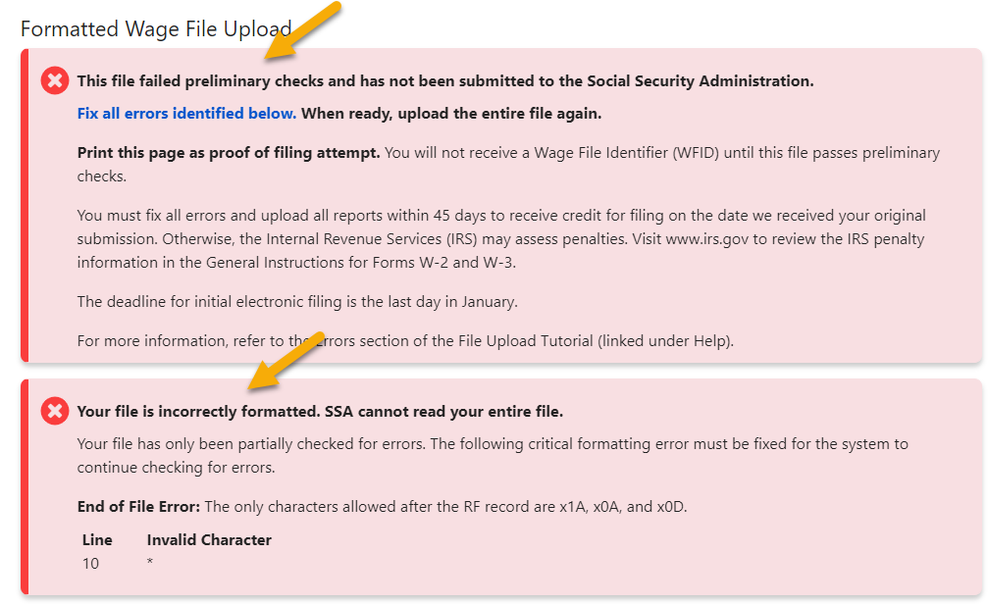

Errors on File Format
If your file has format errors, the system will stop checking the file. Some of file format errors are:
  - Invalid Record Identifier
  - Invalid Record Length
  - Record Out of Sequence
  - End of File Error
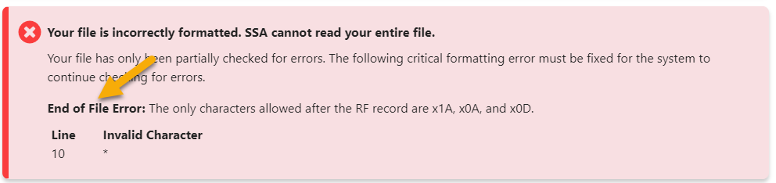

Errors on Field Level
If your file has field level errors, the system will display them in the Error Results section and Error Details section on the failure page. Some of the field level errors are:
- Invalid Tax Year
- Invalid Employer Identification Number (EIN)
- Invalid Tax Withheld Amount
- Invalid Medicare Wages and Tips
- Invalid Money for Annual Household Minimum
- Out of Balance

File Summary
The File Summary section displays:
- The uploading status
- Total wages, tips and other compensation reported if the uploading is a success
- The number of errors detected if the uploading is a failure
- W-3 Forms checked
- W-2 Forms checked
- Date the file was uploaded
- File name
- File size

File Summary for Success
When a file is successfully submitted to SSA, the Status displays “RECEIVED” and the total wages, tips and other compensation reported will be displayed.
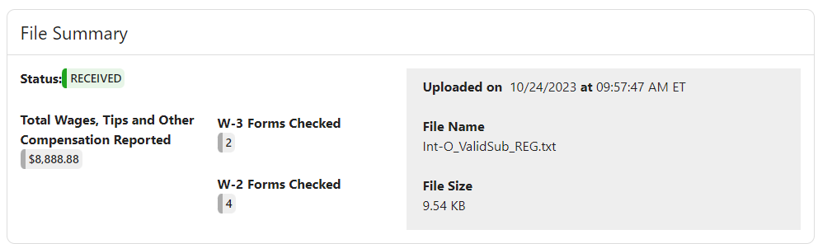

File Summary for Failure
When a file is failed to submit to SSA, the Status displays “FAILED FILE CHECK” and the total number of the errors detected will be displayed. Select the symbol. They system displays Why Does This Count Not Match My File pop up.
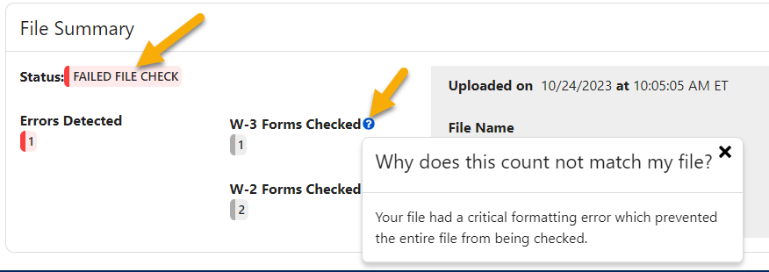

Error Results
The Error Results section displays a Summary of W-3/W-3c Forms with Errors in a table and the Error Details for each W-3 Form in a table. Both tables allow you to sort based on the column headings.
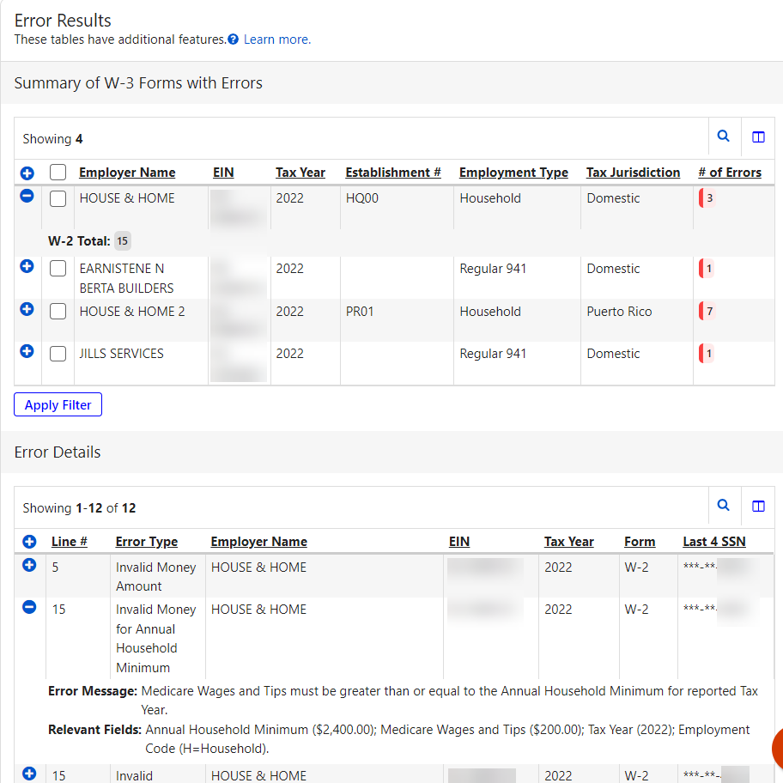
- The Summary table includes Employer Name, EIN, Tax Year, W-2 Total, and # of Errors.
- Error Details table includes the following columns:
  - Line # – indicates the line in the file where the error occurred.
  - Error Type – indicates the type of error that occurred.
  - Employer Name – on the W-3/W-3c.
  - EIN – is the employer’s EIN on W-3/W-3c.
  - Tax Year – is the tax year of the W-3/W-3c
  - Form – displays W-2 if the error occurred on one of the W-2 records (RW- Employee, RO- Employee Optional, or RS- Employee State); displays W-3 if the error occurred on one of the W-3 records (RE- Employer, RT- Total, RU- Optional Total, or RS- State Total).
  - Last 4 SSN – is the last four digits of the Social Security Number
- Select one or more W-3 Forms on the Error Results table, then select the Apply Filter button. The system displays only the Error Details for selected W-3 Forms.
- The system is defaulted to display up to 100 errors per page. If a file has more than 100 errors, the Display rows per page dropdown will be displayed.
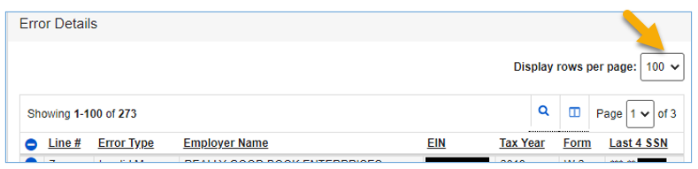
- Select the Search symbol to filter the table by a specific string of characters in any of the table’s columns.
- Select the Column Selector symbol to select the columns you want to display in the table.
- Select the Show symbol to show all the information on a row; select the Hide symbol to hide some of the information on the row.
- The system can display up to 1,000 errors in the W-3/W-3c Summary table. If your file has more than 1000 errors, the system will display the following message:
- The system can display up to 5,000 errors in the “Errors Details” table. If your file has more than 5,000 errors, the system will display the following message:

Other Features—Pop Ups

Acknowledgement of Receipt Pop Up
The Acknowledgement of Receipt pop up can be accessed by selecting the Print Receipt button on the success page.
- Select the Print button to print the Acknowledgement of Receipt pop up.
- Select the X on the top right corner or anywhere off the pop up to dismiss the pop up.
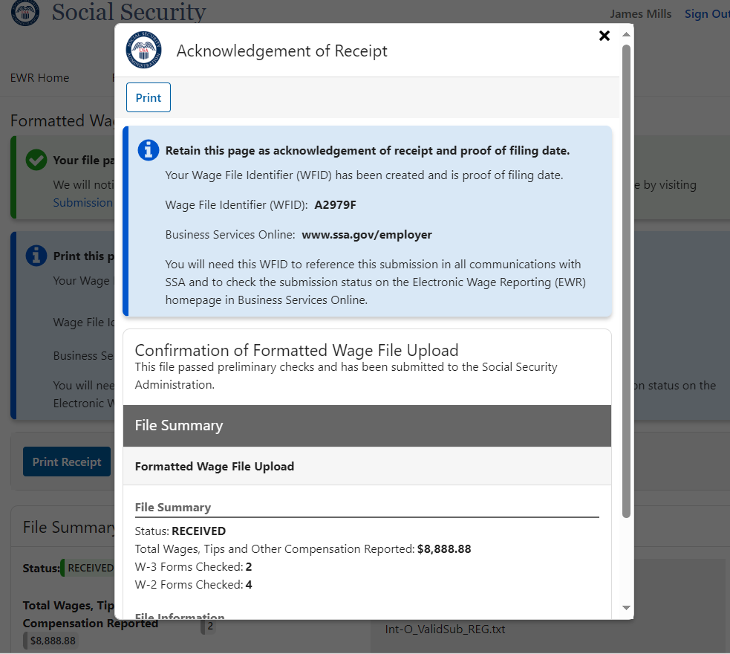

Help Pop Up
The Help pop up can be accessed by selecting the Help link in the header.
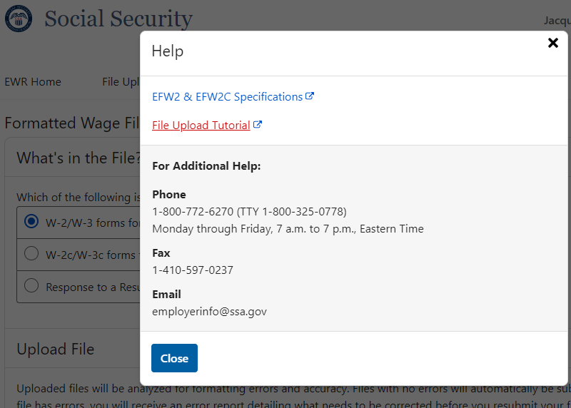

Learn More About This File Format Pop Up
The Learn Moe About This File Format pop up can be accessed by selecting the “Learn more about this file format” link in the Upload File section when either the W-2/W-3 forms for Tax Year 2023 or previous tax year (EFW2) radio button or the W-2c/W-3c forms to correct mistakes on previously processed W-2 forms (EFW2C) radio button is selected.
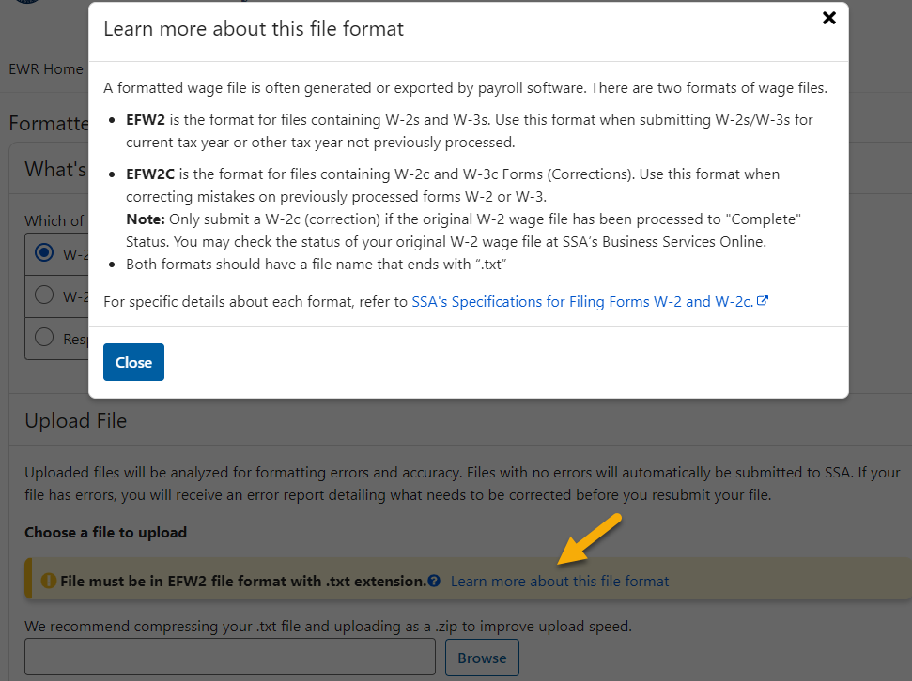

Uploading Your Wage File Is In Progress Pop Up
The Uploading Your Wage File Is In Progress pop up will be displayed when uploading a file if the uploaded file is large.
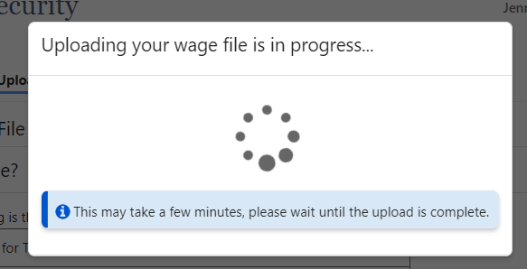

Table Data Loading Is In Progress Pop Up
While the file is uploading, you might see a popup asking you to wait until the table has been loaded.
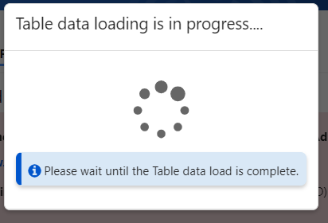

Feedback
User feedback is very important to the performance of Wage File Upload application. The survey link is available on every page throughout the application. You can take the survey more than once. However, you may not want to complete the survey until you submit your wage files.

